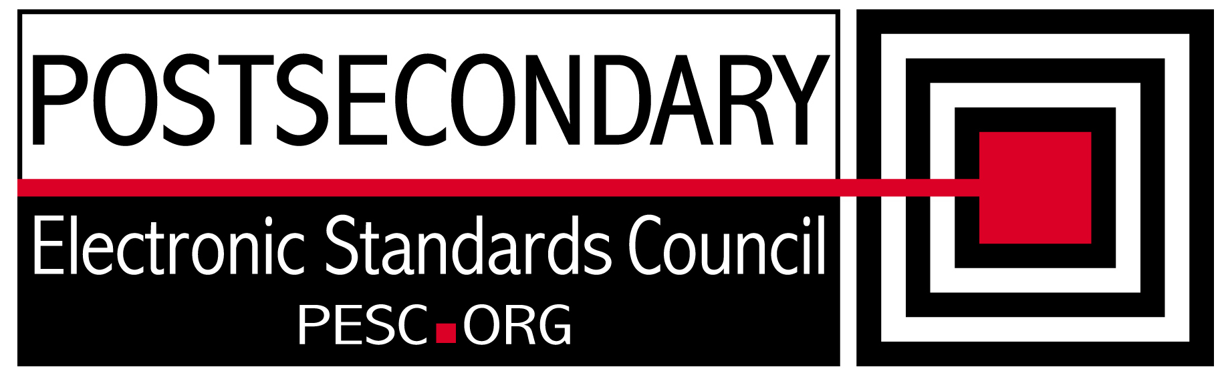

Standards Forum for Education
Status Update Form

Workgroup/Board/Group Name: | Technical Advisory Board
General Summary of Status: | Identified issues that could impede single schema component approach and determined solutions.
Status Flag (Red, Yellow, or Green): | Green
Report Date: | 9/10/2010
Projected Completion Date: | Standing Board
Item | Responsible Resource | Status
Planned Deliverables/Objectives:  - Component Architecture Approach  - Technical Approach to incorporation of CDS  - SIF Architectural Synchronization | Team  Team  Team | Signed off on new R&R functionality. Completed analysis of single schema savings and feasibility  On hold until CDS Implementation team mission is clearly defined  Analysis delayed
Accomplishments/Completions:
- Completed xslt that produces single file schemas
Issues/Obstacles:
- SIFA representative Ron Kleinman has not replied to invitations to participate with the PESC TAB
Assistance Needed:
Chair(s)/Leader(s) Name(s): | Gideon Sanstra, Michael Morris
Meetings/Calls Since Last Update: | 4

Note: Chairs and/or leaders of workgroups, boards and committees under The Standards Forum for Education are required to provide updates during the Steering Committee’s monthly conference call meeting held the second Friday each month at 2:00pm EST. Call in information is: 866-352-3799 *7696363*. Forms must be completed and submitted prior to meeting time. Forms may also be posted on the PESC website as needed to provide the community at-large with a means to obtain updates for ongoing, but yet to-be-completed development efforts.

